1. Describe the mechanism which causes the movement of the tectonic plates. Feel free to use a diagram to assist your explanation. (3 marks)

___________________________________________________________________________

___________________________________________________________________________

___________________________________________________________________________

___________________________________________________________________________

___________________________________________________________________________

___________________________________________________________________________

1. Referring to the map image below, explain what the ‘hot spots’ mean and explain the high frequency of them in an apparent ring. (3 marks)

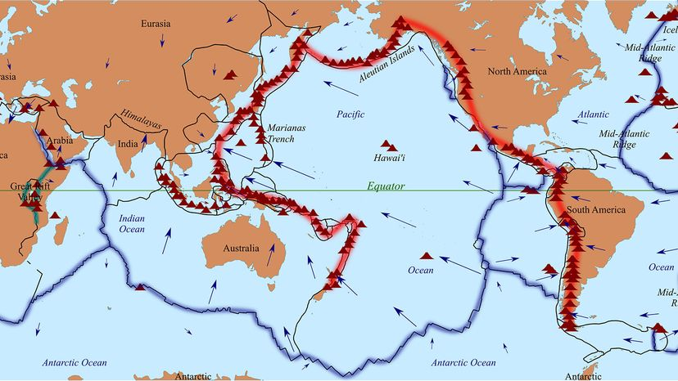

___________________________________________________________________________

___________________________________________________________________________

___________________________________________________________________________

___________________________________________________________________________

___________________________________________________________________________

___________________________________________________________________________

1. Attempt to explain the fact that Australia experiences a relatively low number of earthquakes compared to our neighbouring country, New Zealand. (2 marks)

___________________________________________________________________________

___________________________________________________________________________

___________________________________________________________________________

___________________________________________________________________________

1. Describe what an Earthquake is and explain how they occur. (3 marks)

___________________________________________________________________________

___________________________________________________________________________

___________________________________________________________________________

___________________________________________________________________________

___________________________________________________________________________

___________________________________________________________________________

1. Label the following diagram of an earthquake (5 marks)

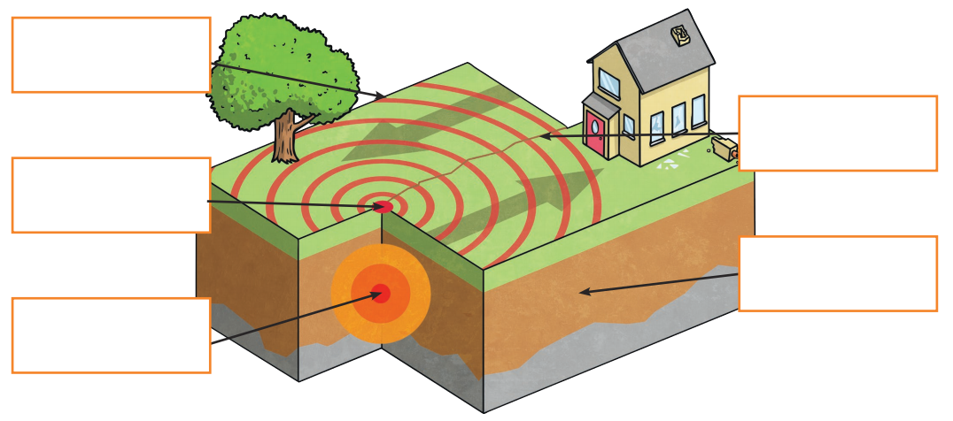



1. Explain the difference between magnitude and intensity in the context of Earthquakes. (4 marks)

___________________________________________________________________________

___________________________________________________________________________

___________________________________________________________________________

___________________________________________________________________________

___________________________________________________________________________

___________________________________________________________________________

1. Describe what a Tsunami is and explain how they occur. (3 marks)

___________________________________________________________________________

___________________________________________________________________________

___________________________________________________________________________

___________________________________________________________________________

___________________________________________________________________________

___________________________________________________________________________

1. Describe one method of minimising damage caused by Earthquakes or Tsunamis. (3 marks)

___________________________________________________________________________

___________________________________________________________________________

___________________________________________________________________________

___________________________________________________________________________

___________________________________________________________________________

___________________________________________________________________________

The El Niño Southern Oscillation (ENSO) has a significant impact on climatic conditions to the East coast of Australia as well as other regions throughout the Pacific Ocean.

1. With the help of diagrams, describe the three phases of ENSO in terms of atmospheric pressure and prevailing trade winds, surface water temperature, cloud cover, and resultant weather.

Normal phase: (5 marks)

___________________________________________________________________________

___________________________________________________________________________

___________________________________________________________________________

___________________________________________________________________________

___________________________________________________________________________

___________________________________________________________________________

___________________________________________________________________________

El Niño: (5 marks)

___________________________________________________________________________

___________________________________________________________________________

___________________________________________________________________________

___________________________________________________________________________

___________________________________________________________________________

___________________________________________________________________________

___________________________________________________________________________

La Niña: (5 marks)

___________________________________________________________________________

___________________________________________________________________________

___________________________________________________________________________

___________________________________________________________________________

___________________________________________________________________________

___________________________________________________________________________

1. Explain, with respect to ENSO, how the likelihood of certain natural disasters may increase along the East coast of Australia during the El Niño or La Niña phases compared to normal weather conditions. (6 marks)

___________________________________________________________________________

___________________________________________________________________________

___________________________________________________________________________

___________________________________________________________________________

___________________________________________________________________________

___________________________________________________________________________

___________________________________________________________________________

___________________________________________________________________________

___________________________________________________________________________

___________________________________________________________________________

___________________________________________________________________________